Site Reference and Name (e.g. Site A: Land at Rundown Industrial Estate, Haddenfield)
Address | - Insert Address
Site Area (Ha) | - Insert site area (e.g. 3Ha)
SHELAA Ref. | - Insert reference (if applicable)
Description | - Please provide a commentary on the site and adjacent land uses.  - Include a site plan showing ‘red line’ boundary of the site put forward for consideration.  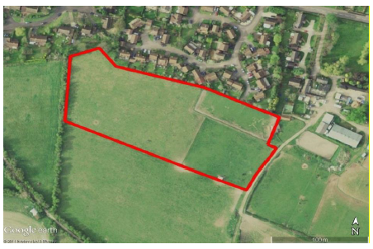  - Include photograph of the site (include potential access points and significant views in and out of the site).  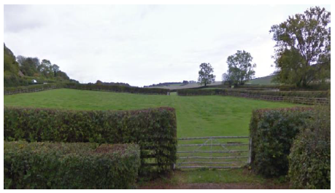
Site Capacity | - Density considerations are dependent on location, design, planning policy  - What proportion of the overall housing requirement for the settlement does this site accommodate?
Planning History | - Relevant planning history
Infrastructure | - Are utilities readily available (gas, water, electric)
Conformity with Local Plan Policies | - What is the current land use designation?  - Cross-reference with the local plan policies in the HDPF.  - Is the site in ‘general conformity’ with the policies in the adopted HDPF?
Opportunities | - Would this site accommodate a particular housing need?  - Opportunity for Regeneration?  - Opportunity for community infrastructure? (e.g. new pedestrian links)
Constraints | - Highlight any insurmountable constraints (flood zone 3 for example)  - Highlight any significant infrastructure constraints in the locality  - Can any of the constraints be mitigated? Consult the relevant agencies if required (Environment Agency/Natural England/Historic England/WSCC)  - Please draw on the data collated in the site assessment template.
Conclusions | - Please consider all the information presented  - Is the site is suitable, available and viable? If yes, is it appropriate as an allocation in the neighbourhood plan OR site is not currently deliverable or developable [state reasons and refer back to the Site Assessment Form].
Summary of Sustainability Appraisal of this site | - This section to be filled in once SEA/SA (if applicable) has been completed.  - Does the site score well in sustainability terms?  - Does the SA/SEA assessment recommend further mitigation to the site or policy to make the proposal more sustainable?

