Invasion Games - Virtual Schools Competition

Basketball

Individual – How many points can you get in 45 seconds?
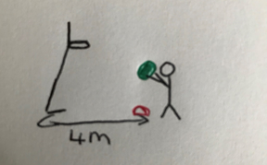
Players stand behind a cone 4m away from the hoop. They take as many shots as they can in the time allocate, retrieving the ball themselves and return to the cone in between shots. Player can use any technique to throw the ball.

Miss = 0pts Rim/Backboard = 1pt basket = 2pts

Team – How many lengths can your team do in 3 minutes?

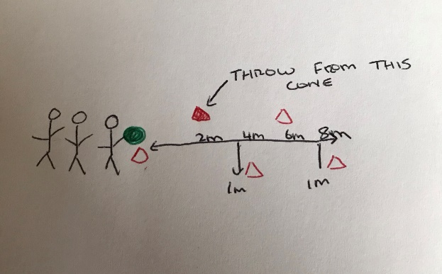
A teams of 3 takes it in turns to run the slalom as many times as possible. They have to dribble to the end cone and back then throw the ball to their teammate from the last cone on the way back. Feet must go around all of the cones as they complete the slalom, if not they will be asked to go back to that cone. One handed dribbling is encouraged, but double dribbles will not be penalised. Traveling will be penalised. If they lose control of the ball they just retrieve it themselves and return to the spot control was lost. Distance in a straight line would be 8m with cones staggered at 2m, 4m, 6m and 8m (1m away from centre line)

1 point for each length completed in the time e.g. to the end and back is 2 points.

Rugby

Individual – How many points can your pair get in 1 minute?

Hoops to be set 1m apart and teammates to face each other. Teammates must throw and catch the ball working their way further and further apart. Once the pair have made two consecutive catches the designated person moves to the next hoop. One hoop must stay in the hoop when throwing and catching. If the catch is not made then the pair continue to try from that hoop until the time runs out or they manage to make a catch and move back.

Each hoop the pair are successful from gives them 1 point.

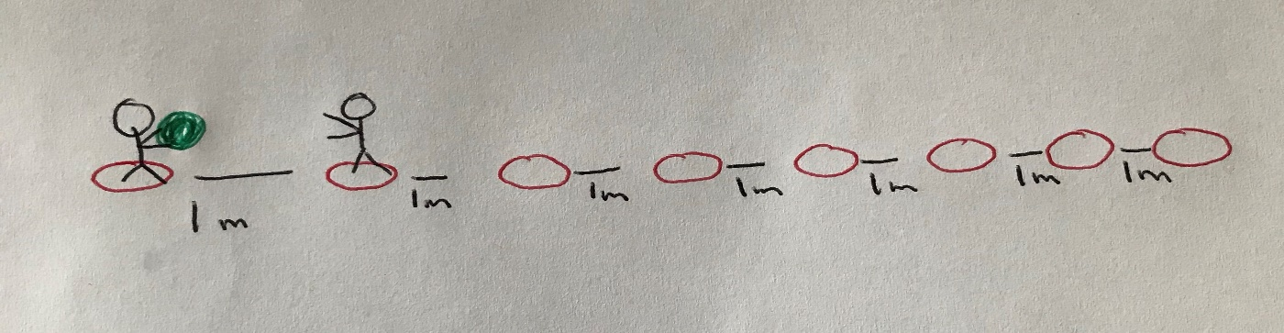

Pairs – How many times can you get from one side to the other throwing the ball?

Hoops to be set 2m apart. The first person must pass the ball to their teammate standing in the next hoop then run past them to the following hoop for their partner to do the same. This keeps going until they reach the final hoop and then they repeat it going back the other way. At least one foot has to stay in the hoop when throwing and catching.
10m length indoor (5 hoops) / 16m outdoors (8 hoops)

Each time you reach the end cone your pair gets 1 point.

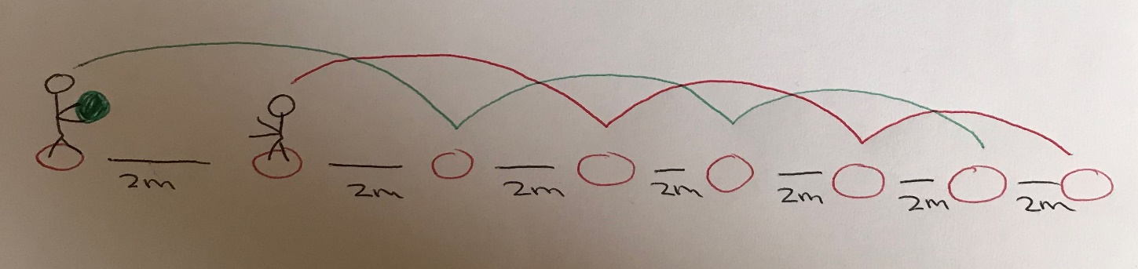

Football

Individual – How many points can you score from 9 shots (1 min max)?

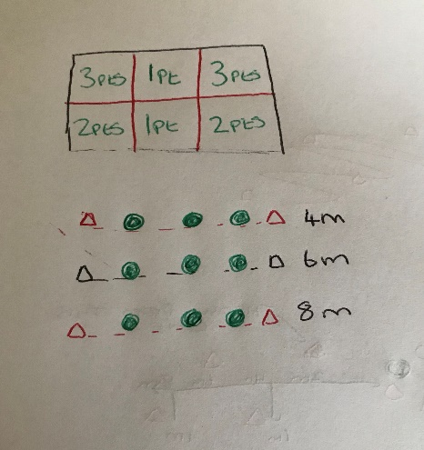

Using the handball goal, which will be split into 6 sections, shoot and score as many points as possible. Each player get 9 shots each and a maximum of 1 minute to take them. The 9 shots will be split into 3 from 4m away, 3 from 6m away and 3 from 8m away.

Points scored depending on the section of the ball that is scored in.

Pairs – How many points can you score in 90 seconds?

In pairs, their aim is to pass the ball through the gate from different distances to score point. Standing behind the maker cones pass the ball to your teammate with it passing through the gate in the middle. The gate in the middle will be 1.5m apart. The distance between the pair will gradually increase every 30 seconds. First 30 seconds will be from 2.5m away, second 30 seconds will be from 5m away and the final 30 second will be from 7.5m away. The pass must be from behind the marker cones or it will not count. The player must use any control/kicking technique.

Each successful pass through the gate earns 1 point.
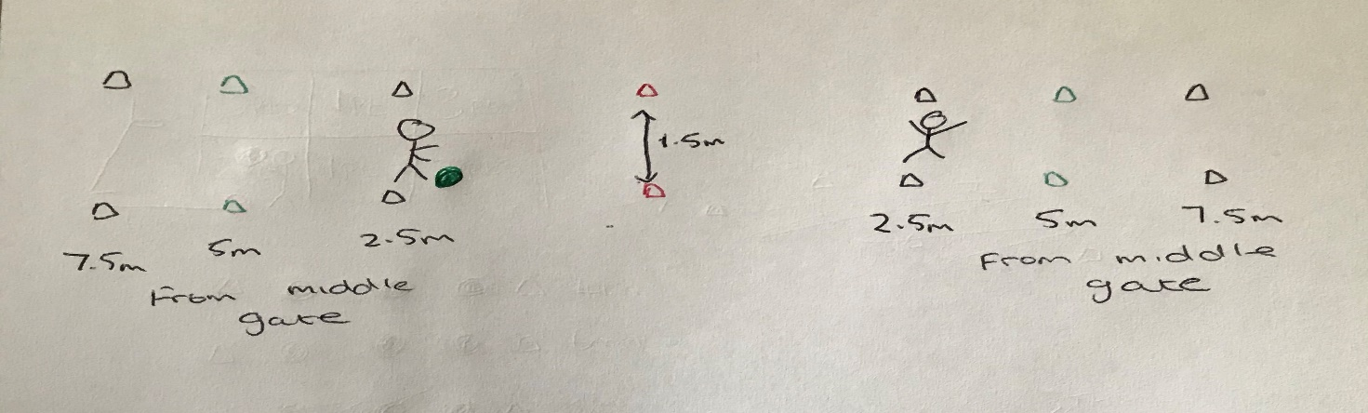

Hockey

Individual – How many points can you score in 45 seconds?

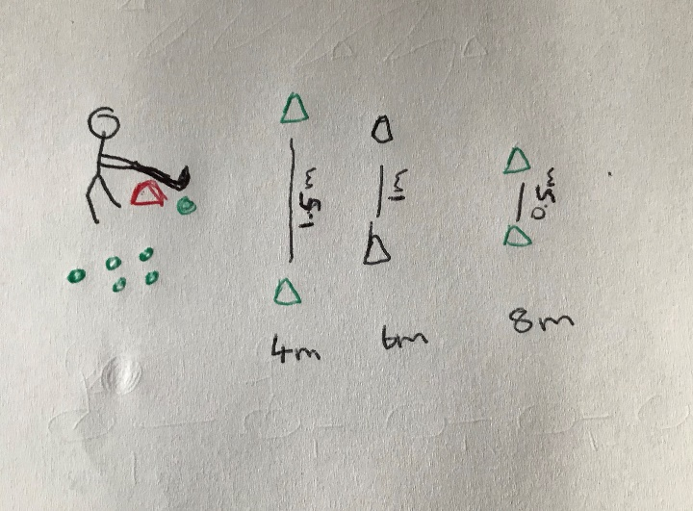
Each player gets 6 balls and has to try and score by passing the ball through the designated gate. The first two balls are to be passed through gate 1 which is 4m away and 1.5m apart. The second two balls are to be passed through gate two which is 6m away and 1m apart. The final two balls are for gate three which is 8m away and 0.5m apart. If the ball hits any part of the cone of the gate the point does not count.

Each successful pass through a gate means 1 point.

Team – How many times can your team complete the slalom relay in 4 minutes?

The players take time to complete the slalom relay as many times as possible to score points. They must go through the cones, all the way to the end and back then leave the ball in the hoop for the next person in line to collect and have their turn. The ball must only be moved with the stick, even in and out of the hoop. The slalom to be 8m in total with cones 1m apart. All the way to end and back is 1 point.

Dribble the ball to the end and back to earn a point.

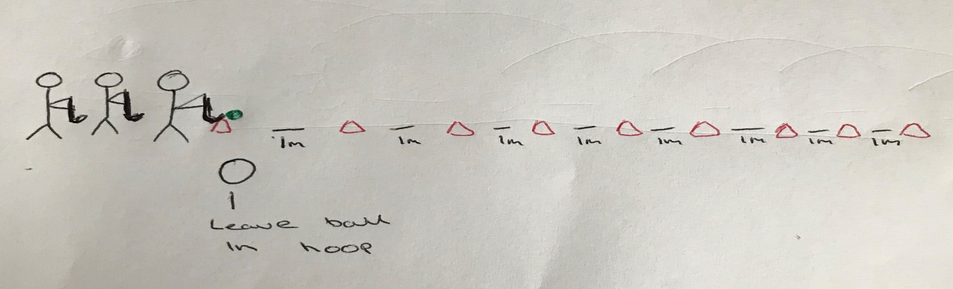

Netball

Individual – How many points can you score with 6 shots

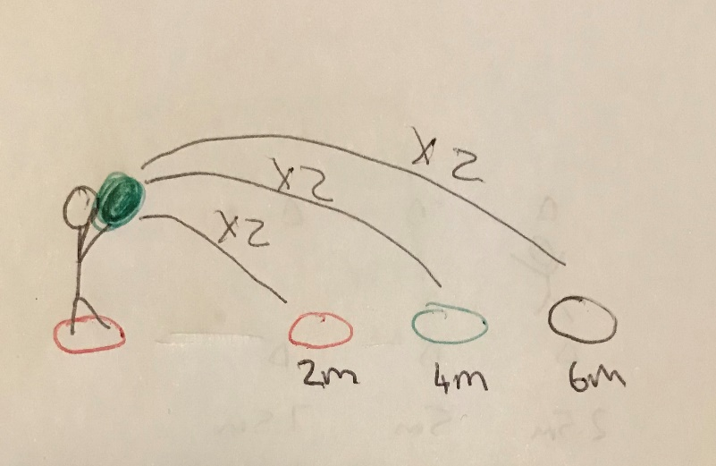
Each player has 6 shots and a maximum of 45 seconds to take them to try and score as many points as they can. The hoops are set out at 2m, 4m and 6m. Scoring into the first hoop is worth 1 point, scoring into the second hoop is worth 2 and scoring into the third is worth 3. The six shots are split into 2 attempts at each hoop. Players must shoot with the ball above shoulder height (no underarm or push pass type throws). Coach to return the ball after every shot. If the ball hits the hoop that also count as a successful shot.

Getting the ball to land in a hoop scores you either 1, 2 or 3 points

Team – How many points can you score in 4 minutes

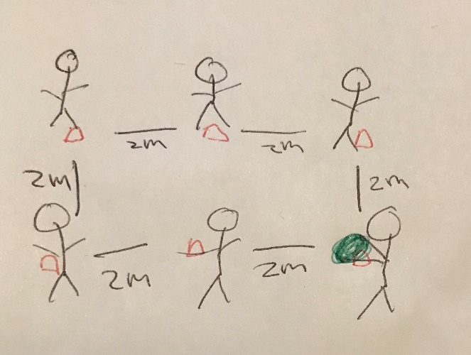
The team stands in a rectangle 2m away from each other. Each player must move the ball around their waist 3 times and then throw in to the next player who does the same. Each time a team member successfully moves the ball around their waist and then throws it to the next person they earn a point, regardless of whether or not the next person catches it. If the next person drops the ball then they just collect it, go back to their spot and then complete their turn. If the person moving the ball around their waist drops it they just pick it up and continue from where they were. For example, if they were on their second rotation when they dropped in they are still on 1 and need to do the second and third rotation before passing.

Moving the ball around their waist 3 times and passing the ball earns a point.

